Public School Crisis

Does Chicago’s Welcoming School Program Improve Enrollment?

Linh Anh Le – Jackson Amodeo

Econ 380 Senior Seminar

**Introduction**

Chicago Public Schools is a microcosm for the decline of public schools in America. Chicago’s has been dealing with a decreasing pool of funding and a shrinking population over the past three decades. There are few successful models to deal with this issue, and their results are muddled. In 2013 Chicago tried closing schools and refocusing funds. We believe that this model can be effective in retaining student enrollment in the long run.

Public schools are the heart of many communities, and closing them sends a message that the district has given up on that neighborhood. Parents lose trust in a school system that is low on funding and getting poor results. To counter these effects and regain the trust in parents, Chicago Public Schools (CPS) introduced a welcoming school program. The program matched each closing school with a neighboring school, designated to accept the stranded students, and gave extra funds to assist the transition. The three criteria for a welcoming school were close proximity, good standing, and available seats. For proximity, the school had to be within a one mile radius of the closed school. To be in good standing, it had to have an overall performance score at or above that of the closing school. Finally, it had to have enough capacity to fit all the closing school students, should they all attend.

Once the schools were decided, they were given support in the form of an information campaign, Safe Passage program, and direct funding. The information campaign consisted of newsletters, calls, and emails to parents, encouraging families to attend the matched welcoming school, and informing them of the extra funding. Since the majority of closed schools were in impoverished and high crime neighborhoods, a major concern for parents was safe commutes for their children to the new schools. To address this, CPS introduced a Safe Passage program to increase safety for students. With a 7.7 million dollar budget, Safe Passage hired additional school buses and crosswalk guards to reduce risk for students. The last part of the program was direct investment into the schools. This included more money to hire teachers, organize STEM, IB classes, fine arts, tutoring, equip more technology. On top of this, principals were each given lump sums to distribute to their schools’ specific needs.

The main question of our research is what was the impact of the welcoming school program on enrollment. We further wanted to discover what other factors impact enrollment. We predict that the program will increase enrollment, but it is unclear what effects other school specific factors will have

**Literature Review**

School closure is a political and controversial topic, implemented under an effort of school districts to use resources more efficiently and save money. The literature on this topic is still limited, most of which focuses on school closure’s impacts on students before, during and after their schools were shut down. However, there is also evidence of school closure’s effects on parents, community and the whole district.

School closure happens due to multiple specific exogenous and endogenous factors, namely weak academic performance, underutilization, and low condition of school buildings (Gwynne & de la Torre, 2009), which meant the schools were not randomly chosen to be closed. In order to deal with selection bias, most of the research on school closure’s impacts on students used different types of quasi-experimental methods. Gwynne,& de la Torre (2009), Graw, Hojman, Mizala (2018), and Larson (2014) used propensity matching scores between two groups. One was the treatment group that went through school closure, and the other was the control group of comparable students with similar backgrounds, similar academic performance, and attending low performing schools but not going through closure. Kirshner, Gaertner and Pazzoboni (2010) did quite similar work, but added one more control group of students who were the post cohort students of the closed school. Kemple (2015) used a popular education research method called Comparative Interrupted Time Series (CITS). Carlson and Lavertu (2015) used difference in difference with the growth of students before and after the school closure. One common thing among these papers is the very large and continuous data set of student level information through a long time period from the school districts, including both background, education performance like GPA, standardized tests, where they went after their school closed which helps increase the validity of the research.

Besides the limits in the available literature, the research also did not show consistency in their findings on school closures’ impact on students. Kemple (2015) and Carlson and Lavertu (2015) showed that school closure actually led to improvement for students of the closed school despite the presumption that this sudden change would detrimentally affect students. Kemple (2015) focused on New York city school closure due to the factory style within the 2002-2008 timeframe. Using CITS analysis on data of the student cohorts four years before the school closed, which calculate the student’s expected test score by using the same school post-closure cohort’s data, Kemple (2015) showed that the phase-out process, the time from the school closure’s announcement to the actual shut down, did not have significantly systematic impacts on students’ academic performance and attendance, but increased in projected graduation rate. Kemple (2015) also examined the after school closure period, and claimed that the students coming to other schools got higher graduation rate, many more of whom earned the prestigious diploma, better long term attendance and 9th grade credit accumulation.

Carson and Lavertu (2015) examined the academic growth of both public and charter schools’ third to eight graders who went through the school closure in Ohio. This is by far the first research on charter school shutdown. Most students showed positive changes in academic growth, especially the correlation of closed charter school even had a strong positive correlation with students’ mathematics performance by the third year. This research also emphasized that where the students went after leaving the closed schools mattered a lot to their growth. Charter school students were more likely to switch to a better school than public school students. 93% of closed public schools students continued to attend another public schools while charter schools students were more likely to switch sectors.

On the contrary, there was research on the negative impacts of school closure on students’ performance, including test scores (Gwynne & de la Torre, 2009), drop out rate and high school graduation rate (Kirshner, Gaertner & Pazzobini, 2010). Gwynne and de la Torre (2009) said that during the 2001-2006, most students from CPS’s 44 closed schools went to a lower performing school. Only a small portion of them went to a better school, which required more travelling out of their neighborhood. This was different from the findings in the New York city’s case investigated by Kemple (2015). In general, there has been no evidence of long term impact after the closure of schools on students (Brummet, 2012; Gwynne and de la Torre,2009; Gordon et.al, 2018). Indeed, in the case of Michigan’s school district, students quickly recovered, even when their test scores were so poor before the closure (Brummet, 2012).

While the majority of literature was the U.S centric, we found one research talking about the massive school closure in Chile. Chile has applied a universal school voucher program, privatization of education system and the idea of free market in education in large scale. From 2002 to 2011, there were 1282 schools closed in Chile, accompanied by 2350 new schools, mostly private voucher schools. Using propensity matching score and instrumental variable (IV), Grau, Hojman and Mizala (2018) showed that school closure increased the high school drop-out rate and grade retention rate at 10% significance level, among the displaced students. The instrumental variable used in this research was school enrollment, in order to measure the impact of school closure to grade retention rate. We agree with the author’s reasoning; however, this may only be applicable to Chile’s schools where school revenues are proportionate to enrollment and schools have minimum enrollment requirement to secure the budget.

School closures also affected students who had been in the new schools where displaced students would transfer to. These schools are called by different names, among which receiving schools, recipient schools or welcoming schools are the most popular. Brummet (2012) showed that both displaced teachers and displaced students created a negative but modest impact on the receiving schools, which faded over time. Larsen (2014) said that increasing the proportion of new students who were displaced due to the closing of their schools in the whole student body had positive impact on a student’s GPA. This result contradicted to Brummet (2012), which could be due to exogenous factors like teachers’ empathy with new students. “Having many new students may affect how teachers grade their students, potentially grading easier to compensate for the many new students” (Larsen, 25). Our research would investigate more the closure’s impact on schools, particularly, welcoming schools and their comparison schools.

While there was some research on student’s academic performance and attainment, there was only one that focused on the emotional changes among displaced students. Through a participatory action research project with former students of a closed school, Kirshner, Gaertner and Pazzobini (2010) found out some common themes in students’ experience. Students did not see their school being shut down as an opportunity, but rather an imposed decision. Students had to deal with disrupted relationships with friends, weaker relationships with school adult, and the stereotypes for coming from a closed school. This qualitative research is insightful, and was done carefully through different methods, including surveys for 95 students, peer interviews and focus groups.

Beyond the effects on the students, the districts were looking for significant economic results from these school closures. Examining the goals and results of the closure at a district level gives context to the student performance data. CPS went into the 2013 year with 28,289 less students than then in 2000 according to Vevea and Lutton (2013). To more efficiently use space, they cut back schools with the goal of saving $560 million dollars in capital expenses over the next 10 years. In reality, Vevea and Lutton showed a real savings of 437.8 million based on building assessments. The issue with closing schools is the empty buildings are rarely sold or taken advantage of (Samuels, 2001). They are often in declining neighborhoods and in poor upkeep (Mari, 2013). This makes it difficult to sell the empty buildings to new businesses and investors. Mari says, school board members expect selling old buildings to produce significant revenue, but it seldom follows through.

Larry Eichel, program director for the Philadelphia Research Initiative, says buildings are just a small piece on the board. “The savings are under a million dollars per school,” Mr. Eichel said. “That’s real money, but not money that changes anything fundamentally.” In the context of Philadelphia's $2.8 billion budget, a few million is of little consequence. Eichel and Samuels both say that the majority of a school district’s budget goes toward teachers and support staff, both of which are still needed after closures.Therefore, without massive layoffs accompanying school closure, little money is saved.

What they do save is cut by the $329 million of bonds CPS is selling to finance new capital investments and turn around declining schools. Lutton (2013) says CPS’s financing is brought with a $25 million annual debt service over the next 30 years, cutting into its future budget. Despite the limited financial benefits of school closure, it still saves money in the long term, but leaves parents wondering where to send their kids.

Cowhy et al. of the University of Chicago Consortium on School Research (2018) did a mass phone survey of parents, teachers, staff, and students across Chicago in 2013. They found teachers, parents, and students described the school closings "chaotic" but a few things like "safe passage routes" and additional funding for welcoming schools helped mitigate the transition. Of the students required to find a new school, one-third opted out of a welcoming school, because parents did not define academic quality with the official district performance rating system. Cowhy et al. found parents preferred close schools, after school activities, small class sizes, positive school environments, and one-on-one attention from teachers. Samuels (2011) says these reasons cause more parents to choose charter over public schools during closures.

**Theory**

In this research, we focus on the impact of the welcoming school program. Since we did not have any better proxy to measure the success of this program, such as academics, or students’ satisfaction when attending a new school, total enrollment is by far the best measure of the success of this program. We hypothesize that the combined effects of the information campaign, increased funding, and the Safe Passage program, would capture the interest of parents, would increase student enrollment for the welcoming schools after the closures. Previous research also shows that schools that accepted displaced students after their schools got shut down, did not necessarily perform worse than before (Larsen, 2014).

**Data**

**Data Sources and Documentation**

According to de la Torre et al.(2018), the welcoming schools were chosen in school year 2012-2013 based on three main factors. One was the school performance, measured in the scale of 1 to 3 by CPS, 1 being the best performing schools, and 3 being the worst. Most of the closed schools were scored “3” in school performance, although some of them had 2 scores. With a goal to persuade parents to continue sending their children to a school in CPS’s system, the schools that were selected to become a welcoming schools mostly had better scores than the closed schools. Other factors in choosing schools included the availability in school capacity, and the proximity of that school to the closed school, which was within a mile. This research paper focuses on measuring the impacts on total school enrollment of turning an elementary school into a welcoming schools after a neighborhood school got shut down. In order to do this, we use difference in difference model with a panel data set of 10 years, including 5 years before and 5 years after there was a closed school in the neighborhood. There will be two groups in our dataset, namely a treatment group and a control group. A treatment group includes the welcoming schools, and a control group includes neighboring schools that did not get selected to become welcoming schools.

When choosing schools to be in our control group, we tried to find the schools that fit all three criteria, but did not become the welcoming schools to avoid selection bias. de la Torre et al.(2018) showed that a third of parents from 47 closed schools did not decide to send their kids to the designated welcoming schools. This means there were neighborhood schools that did not receive additional funding or support like the welcoming schools but still needed to receive students from the closed schools. We call this group non-welcoming schools. To select those non-welcoming schools, we use the data set called Chicago Public Schools – Elementary School Progress Report Card (2012-2013) from the City of Chicago’s website to get schools’ locations and overall ratings, data from Illinois State Board of Education (ISBE) for schools’ total enrollment and data from CPS for schools’ capacity during school year 2012-2013.

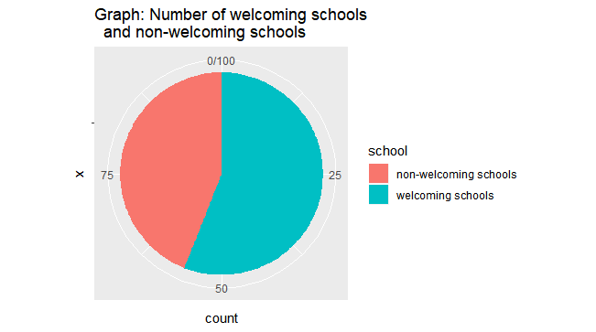

We were able to choose 36 schools which, during the school year 2012-2013 witnessed a massive school closure, still had open seats, were located within 1.3 miles, and scored higher or equal to the closed school on the school report card. We extended the proximity from 1 miles to 1.3 miles since we believed the spill-over effect of the school closure could affect other schools in the neighborhood and that the 1.3-mile distance is acceptable. Overall, our dataset investigated 82 schools in CPS’s system during a 10-year period from 2009 to 2018. We use the public data set from ISBE and CPS to get data for our regression model, including total school enrollment, racial compositions, low income rate, the proportion of English learners, parental involvement, mobility rate and attendance rate.

**Descriptive Statistics**

To measure the impact of the welcoming school program in schools’ enrollment, we included 8 independent variables. These variables could be categorized into two smaller groups. Variables about student characteristics include the racial composition variables like the proportion of White, Black and Hispanic students, and the proportion of students being low-income, English learners and with special needs. School characteristic variables include school’s attendance rate, parental involvement, and mobility rate. Table A provides the summary statistics of these variables, as well as our dependent variable.

TableA: Summary Statistics

|  |  |  |  |  |  |
| --- | --- | --- | --- | --- | --- |
| Variables | Obs | Mean | Standard deviation | Min | Max |
| Total enrollment | 819 | 408.93 | 177.29 | 112 | 1572 |
| % White student proportion | 819 | 2.49 | 7.6 | 0 | 68 |
| % Black student proportion | 819 | 80.1 | 33.53 | 0.6 | 100 |
| % Hispanic students | 819 | 14.49 | 27.84 | 0 | 99.2 |
| Parental involvement (%) | 709 | 83.4 | 17.76 | 9.2 | 100 |
| Mobility rate (%) | 817 | 25.84 | 13.8 | 0.5 | 84 |
| Attendance rate (%) | 819 | 94.15 | 1.85 | 86.4 | 98.4 |
| English learner (%) | 764 | 7.06 | 12.8 | 0 | 58.5 |
| Special need (%) | 818 | 21.56 | 23.28 | 2.3 | 99.5 |
| Low income (%) | 738 | 93.52 | 9.91 | 42 | 100 |

Since we investigate 82 schools in 10 years, the maximum number of observations should be 820. For our dependent variables, 1 observation is missing, which is the South Shore school. This school was opened in 2010, as a consequence, there is no data in 2009. According to the table A, the number of observations for each variable was below the maximum 820 observations for. This mostly happened due to random data collection issues. For parental involvement, some schools did not measure, especially the Illinois Board of Education stopped measuring it in school year 2017-2018. For low income students, data was not collected for school year 2008-2009. For the proportion of English learners, there were schools that kept having missing data for this variable, especially in school year 2017-2018. We are not sure why this happened, however, one explanation we could come up with when looking at those schools’ data in the previous years, is that they all had a very small number of students being English learners, almost 0.0% the years before 2018, and ISBE just stopped reporting or measuring this data for them.

Graph: Distribution of total enrollment, 2009-2018

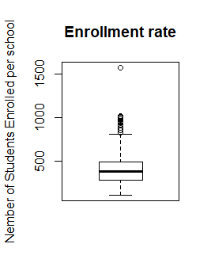

The enrollment rate of each school throughout the ten year period shows that 75% of the schools had less than 500 students, but several schools had 1000 or more students, positively skewing the data. Eliminating these outliers to strive for a more equitable education across Chicago was a goal of the program. On average, there were 408.93 students in a school however, the enrollment varied quite a lot from 112 students to over 1500 students.

Graph: Distribution of proportion of Graph: Distribution of the mobility

low income students, 2009-2018 rate, 2009-2018

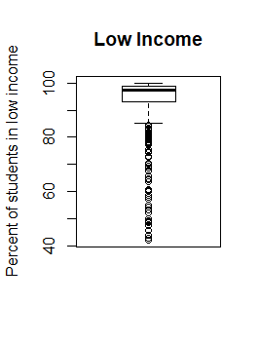 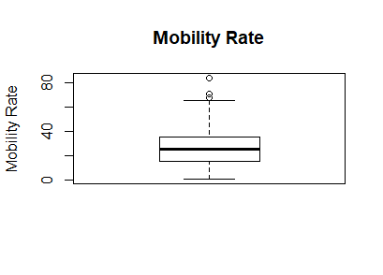

Low income is generally measured as the percent of students in the free or reduced lunch program, but may vary between local education agencies. The graph indicates that more than 75% of schools had greater than 90% of their students on free or reduced lunch. The high rate of low income students and negative skew suggest mostly poor students attend public schools in Chicago, though there are many exceptions. Mobility rate is the number of students that left a school for non-standard (graduation, school closure) reasons. The mobility rate is small enough that it cannot explain the significant change in enrollment seen in the “Enrollment Over Time” graph, further suggesting that the welcoming program was responsible.

Graph: Distribution of parental involvement, Graph: Distribution of attendance rate,

2009-2018 2009-2018

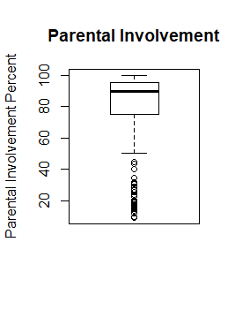 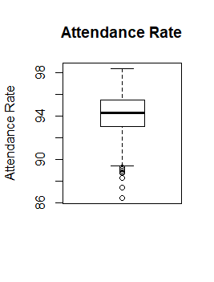

The average percent of parental involvement in each school, 2009-2018, indicates the percent of students whose parents or guardians have had one or more personal contact with the student’s teachers regarding the student’s education. The means are 91% and 94%, respectively. Both parental involvement and average attendance rate for each school, 2009-2018, are negatively skewed.

|  |  |
| --- | --- |
| Graph: The proportion of Black students for each year, 2009-2018 | Graph: The proportion of Hispanic students for each year, 2009-2018 |
| Graph: The proportion of White students for each year, 2009-2018 | |

The box plots that displayed very clearly that the racial composition of schools in our sample size did not change much over the course of 10 years. The skewness remained consistent, with the proportion of Black students being extremely negatively skewed, and those of Hispanic and White being extremely positively skewed. There were around 10 majority Hispanic schools, 1 majority White schools, and 66 majority Black schools. We define majority as a school having more than 50% of its population being either Black, White, Hispanic. According to table A, on average, schools in our sample had 2.5% White students, 80.1% Black students and 14.49% Hispanic students. In this research, our focus is on these three main groups of students, which also aligned with CPS’s focus. There is not enough data on other racial groups to draw conclusions.

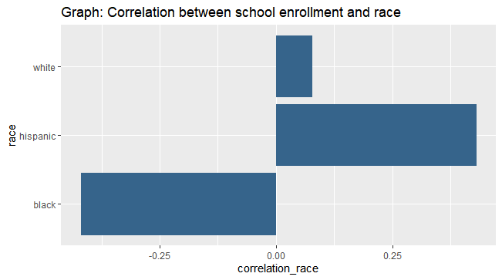

The racial composition of the schools also shows an interesting pattern in its correlation with school total enrollment. The correlation between the proportion of White students and student’s total enrollment is only 0.08, which is very close to 0. This also means that the proportion of White students did not have any correlation with the school enrollment, which was reasonable, because the schools in our data set are located in the area that are majority Black or Hispanic. Chicago is a highly segregated city, and during the massive school closure in 2013, most of the closed schools were located in the area with a highly dense African American or Hispanic population, such as South Side, West Side, Near West Side, and Greater Calumet. We also needed to take into consideration that there were some missing data for White students in our data set, probably because of the low proportion of White students in that school that the Illinois Board of Education did not include that in their data set. An interesting trend was observed between the proportion of Black and Hispanic students. The correlation for the proportion of Black students with total enrollment of the school in our sample set was -0.43 while that for Hispanic students was 0.45. This could be interpreted as the higher the percentage of student population being Black, the lower the school’s total enrollment. While on the contrary, high percentage of Hispanic students correlated with high student enrollment..

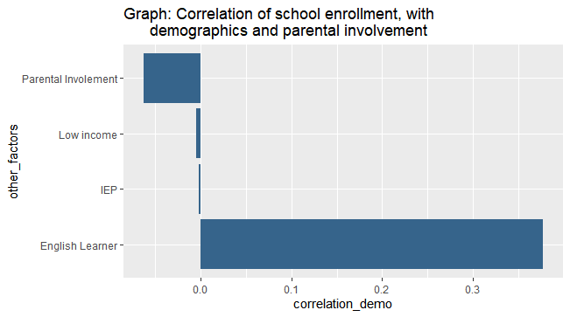

The proportion of students coming from a low-income family and students who needed special education was almost not correlated with the school enrollment in our data set. However, the proportion of English learners was positively correlated with total enrollment, at 0.37. This may be true, given the fact that many schools in our sample set were majority Hispanic, and consequently, the students’ first language may be Spanish. In addition, with parents not speaking English, there would be a higher chance for a student going to an assigned neighborhood school. Contrary to our expectation, which was the more parental involvement, the higher the school enrollment, the correlation between these two variables was negative. Even though the correlation was not extremely high, it is still worth investigating why parental involvement could be negatively correlated with the number of students enrolling in a school.

Besides looking at how all independent variables correlated with student enrollment of these schools, we also examined correlations among independent variables

Graph: Correlation between variables

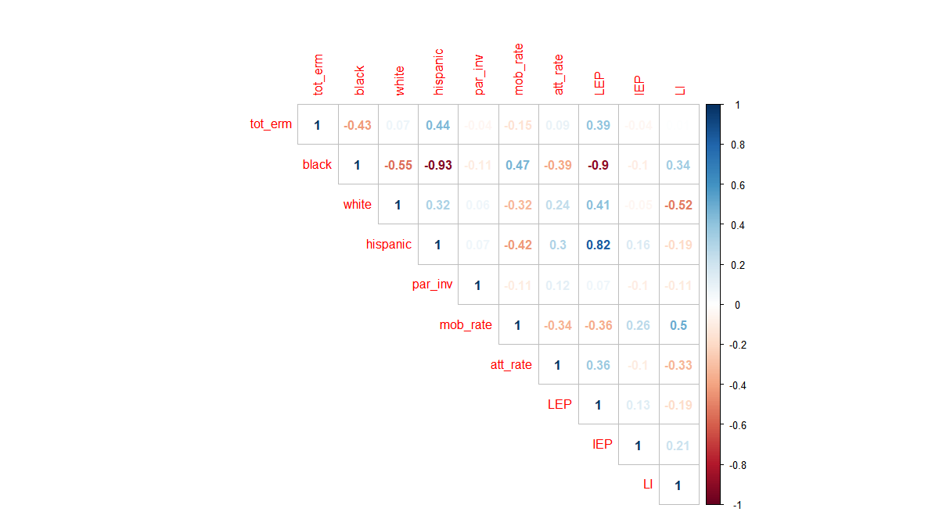

Overall, there is no particular strong correlation between most of the variables, except for the proportion of Black students, Hispanic students and English learners. The graph shows that there is a strong negative relationship between the proportion of Black and Hispanic students, which makes sense, because Chicago is still a highly segregated city. However, this strong correlation is only between Black and Hispanic students, not between White students and other students, which demonstrates an interesting stories among minority and underprivileged groups of students. Not surprisingly, English learners and Hispanic students are positively correlated. Many Hispanic students speaks Spanish as their first language, which increases their chance of being classified as English learners and students who need more help with English. The proportion of Black students had an inverse relationship with Hispanic students, thus a negative correlation with the proportion of English learners.

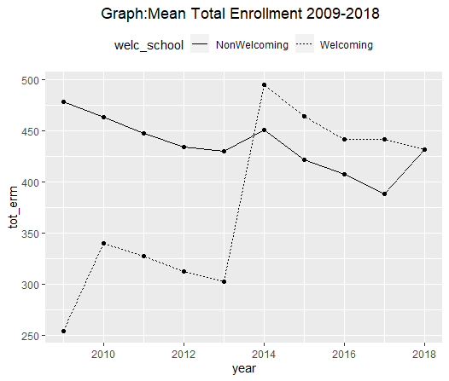

The above graph shows how the average total enrollment of each school (y-axis) changed over 10 years. The jump in welcoming school enrolment from 2013 to 2014 is indicative of the new students transferring from the closed schools. A key factor in choosing the welcoming schools was their capacity for taking in new students. The smaller jump among schools in the control group indicates the third of students who chose not to go to their designated welcoming school. From this graph, we could say that there was a big increase in enrollment happening to the schools after the treatment, however, it is unclear whether this change is statistically significant and caused by the treatment or not. That is why we will conduct difference in difference method later to test this. Despite a sudden change that happened in 2014, we still see the general downward trend in enrollment which is a result of the steady population decrease of Chicago (“Chicago, Illinois Population” n.d.). The school closure and the welcoming schools program seemed to be most effective on school enrollment when happening together, but they both became ineffective when placing under the chronic issue of shrinking student population that the whole CPS system experienced.

Table B: T-statistics of welcoming schools and non- welcoming schools,

before treatment, 2009-2013

|  |  |  |  |
| --- | --- | --- | --- |
|  | Welcoming schools | Non welcoming schools | T-value |
| Total enrollment | 327.42 | 450.66 | 6.73 |
| % White students | 1.51 | 3.43 | 2.64 |
| % Black students | 83.02 | 76.35 | -1.92 |
| % Hispanic students | 13.56 | 16.07 | 0.87 |
| Parental involvement (%) | 87.87 | 87.86 | -0.01 |
| Mobility rate (%) | 28.85 | 22.9 | -4.34 |
| Attendance rate (%) | 93.55 | 93.88 | 1.56 |
| English learner (%) | 5.26 | 7.01 | 1.47 |
| Special needs (%) | 29.66 | 26.93 | -0.88 |
| Low income (%) | 94.28 | 92.1 | -1.88 |

To understand the welcoming school program’s effects on schools in our sample, we conducted a t-test between the two groups before the treatment (table B). For t-test, t-value is important. When the t-value is bigger than 2, the difference in mean is statistically significant. In general, two groups were not so different from each other, except for their enrollment, the proportion of White students and mobility. Total enrollment in welcoming school is statistically lower than that of non-welcoming schools before the treatment. This makes sense, because the welcoming schools had lower enrollment before the program, and thus were chosen for it. On average, the proportion of White students in both groups are low, 1.51% for welcoming schools and 3.43% for non-welcoming schools. The t-test shows that this gap in White student proportion is statistically significant among the treatment and the control group. Welcoming schools, on average, had much higher mobility rate than non-welcoming schools at high t-value of -4.34. The negative significance of mobility rate suggests that more students leave the welcoming schools than others.

Table B: T-statistics of welcoming schools and non- welcoming schools,

before and after the school closure

|  |  |  |  |  |  |  |  |
| --- | --- | --- | --- | --- | --- | --- | --- |
|  | Welcoming schools | | |  | Non-welcoming schools | | |
|  | Pre-closure | Post-closure | T-values |  | Pre-closure | Post-closure | T-values |
| Total enrollment | 327.4279 | 448.8913 | -10.304 |  | 450.6556 | 419.8333 | 1.3743 |
| % White students | 1.510044 | 1.620313 | -0.3037 |  | 3.432222 | 5.023179 | -1.2788 |
| % Black students | 83.02576 | 83.45217 | -0.1468 |  | 76.35333 | 75.43222 | 0.24206 |
| % Hispanic students | 13.55764 | 14.14104 | -0.227 |  | 16.07056 | 17.44198 | -0.439 |
| Parental involvement (%) | 87.87445 | 74.65385 | 6.9174 |  | 87.86441 | 80.96838 | 3.717 |
| Mobility rate (%) | 28.85197 | 28.91130 | -0.0481 |  | 22.89722 | 20.95955 | 1.3505 |
| Attendance rate (%) | 93.55415 | 94.40652 | -5.5036 |  | 93.88333 | 94.86500 | -4.8079 |
| English learner (%) | 5.259389 | 7.338384 | -1.7477 |  | 7.012222 | 9.380255 | -1.5918 |
| Special needs (%) | 29.65764 | 16.12609 | 6.4949 |  | 26.92722 | 12.78324 | 6.0633 |
| Low income (%) | 94.27663 | 95.63522 | -2.1731 |  | 92.09722 | 91.17222 | 0.64168 |

We also conducted t-test on each group before and after the welcoming school program is implemented to see whether this program changed the schools in any aspects. During a 10-year period from 2009, the racial composition of both welcoming schools and non- welcoming schools changed before and after the school massive closure. However, the difference between the before and after treatment was not significant (t-value <2). This implies that the school closure in school year 2012-2013, combined with some schools being turned into a designated welcoming schools did not have an impact on the racial demographics of both welcoming schools and non-welcoming schools.

The change in the mean of average mobility rate of both welcoming schools and non- welcoming schools from before to after treatment was statistically insignificant, with t-values of -0.0481 and 1.3505. Not only did welcoming schools on average had higher students’ mobility rate than the non-welcoming schools, but they also increased between before and after the treatment while the non-welcoming witnessed a decrease. Turning a school into a welcoming school with a lot more resources did not lower the probability of students transferring in and out. There seems to be more lack of stability in student population in welcoming schools than non-welcoming schools, but this was not caused by the fact that some school became welcoming schools under the decision of CPS.

From table B, the welcoming school program significantly increased the enrollment of welcoming schools but did not affect the non-welcoming schools. This is the expected result that CPS’s administrators would like to see. The treatment also affected some aspects of student’s background and parental involvement in welcoming schools. The difference in mean of parental involvement, attendance rate, students with special needs (IEP), and low income students’ proportion was statistically significant for the welcoming schools, which was an evidence for the impact of welcoming schools on which students decided to enroll in welcoming schools. Non-welcoming schools experienced the similar trend, except for the proportion of low income students. Parental involvement of both groups decreased throughout the time, more substantially among welcoming schools. Attendance rate increased from before and after the treatment for both control and treatment groups of schools. While the proportion of IEP students decreased for both non- welcoming schools and welcoming schools, it is not clear whether the difference was caused by the welcoming schools program or change with CPS’s schools as a whole.

**Empirical Result**

**Empirical Methodology**

In order to test the impact of turning a school into a welcoming school after a nearby school closed, we use difference-in-difference (Diff-in-Diff) method with ordinary least square (OLS) regression. Our dependent variable is total enrollment. Our control variables are racial composition, expressed as the proportion of Black, White, and Hispanic students, students’ characteristics, such as low-income, special needs, and English learner, and schools’ characteristics, namely attendance rate, parental involvement and mobility rate. Here is the base model that we are using to run OLS regression analysis:

Enroll = α +γ Welcoming schoolit + ƲAfter treatmentt + δWelcoming schoolit × After treatmentt + εit

In this model, Welcoming school and After treatment are both dummy variables. Welcoming schools is 1 when the schools were selected by CPS to become a welcoming school, receiving extra funding and being the default option for closing school students to attend. Otherwise, Welcoming school is 0, to represent the matching schools. The matching schools were chosen based on 3 criteria, as discussed in descriptive analysis section ensured the randomness of the schools in our sample set. When after treatment is equal to 1, it refers to the period of post intervention, 2014-2018. After treatment is equal to 0 for years 2009-2013. δ represents the treatment effect on the schools’ enrollment. Further variables were added to our model in order to control for the factors that made the schools systematically different, countering the selection bias issues.

**Results**

Table1 on the next page shows the regression results using the Diff-in-Diff equation. When adding and removing variables from the model, we observed the change of the treatment effect variable as well as other control variables on the school enrollment throughout the researched period (2009-2018). In model 1, we include three variables that explain the treatment effect without adding any other control variables. In model 2 and 3, we include the racial identities of the students into the model to observe how the racial composition of the schools affected its enrollment. Model 4, 5, and 6 shows added other students’ demographic characteristics, as well as schools’ characteristics to model 3.

Table1: Regression results of total enrollment on other factors

|  |  |  |  |  |  |  |
| --- | --- | --- | --- | --- | --- | --- |
|  | (1)  Total Enrollment | (2)  Total Enrollment | (3)  Total Enrollment | (4)  Total Enrollment | (5)  Total Enrollment | (6)  Total Enrollment |
| **Welcoming school treatment effect** | | | | | | |
| Welcoming school(Dummy) | -123.23***  (16.91) | -114.799***  (15.2392) | -115.14***  (15.046) | -103.120***  (16.3205) | -101.23***  (16.49) | -118.254***  (15.094) |
| After treatment (Dummy) | -30.82 **.**  (17.89) | -30.4416 **.**  (16.0231) | -27.94 **.**  (15.83) | -1.791  (17.55) | 2.865  (16.685) | -7.121  (16.502) |
| Interaction | 152.29***  (23.90) | 153.0428***  (7.151) | 149.89***  (21.139) | 149.838***  (22.904) | 147.48***  (21.775) | 146.018***  (21.261) |
| **Students’ demographic characteristics** | | | | | | |
| % Black students |  | -0.3832  (0.4395) | -2.55***  (0.6327) | -4.357***  (0.915) | -4.404***  (0.889) | -4.32***  (0.843) |
| % White students |  |  | -5.0471***  (1.0741) | -5.507***  (1.230) | -5.60***  (1.165) | -6.08***  (1.1298) |
| % Hispanic students |  | 2.3368***  (4.370) | 0.3178  (0.6807) | -0.267  (0.762) | -0.354  (0.748) | -0.491***  (0.713) |
| Low-income (%) |  |  |  | 1.894*  (0.809) | 1.211  (0.778) |  |
| English Learner (LEP) (%) |  |  |  | -1.995 **.**  (1.146) | -1.961 **.**  (1.081) | -2.248*  (1.024) |
| Special needs (IEP) (%) |  |  |  | -6.41***  (1.375) | -6.50***  (1.25) | 0.253  (0.237) |
| **School’s characteristics** | | | | | | |
| Parental Involvement (%) |  |  |  | -0.0298  (0.3487) |  |  |
| Attendance rate (%) |  |  |  | -11.924**  (3.641) | -10.449**  (3.490) | -10.821**  (3.367) |
| Mobility rate(%) |  |  |  | 0.647  (0.531) | 0.690  (0.513) | 0.458  (0.460) |
| Constant | 450.66***  (12.65) | 442.3585***  (43.1903) | 657.31***  (62.54) | 1822.53***  (378.94) | 1749.44***  (364.061) | 1823.717***  (342.42) |
| Observations | 819 | 819 | 819 | 632 | 720 | 801 |
| R2 | 0.08647 | 0.2697 | 0.289 | 0.3581 | 0.343 | 0.3086 |
| Adjusted R2 | 0.08311 | 0.2652 | 0.2838 | 0.3457 | 0.3328 | 0.2999 |
| F-test | 25.71 | 60.04 | 55.01 | 28.78 | 33.6 | 35.26 |
| Note: ‘***’ p < 0.000, ‘**’ p < 0.001, ‘*’ p < 0.1, ‘**.**’ p < 0.05 | | | | | | |

Overall, the coefficient for treatment effect was robust and significant, which means the welcoming program had an impact on total school enrollment during the researched period. In model 2 and 3 about the racial distribution of the schools, we found a significant change when adding the proportion of White students as an independent variable. The coefficient of Black variable and Hispanic variable changed in the opposite direction and Hispanic became no longer statistically significant. One reason we had for this is that the proportion of Black students and Hispanic students in our sample are strongly negatively correlated.

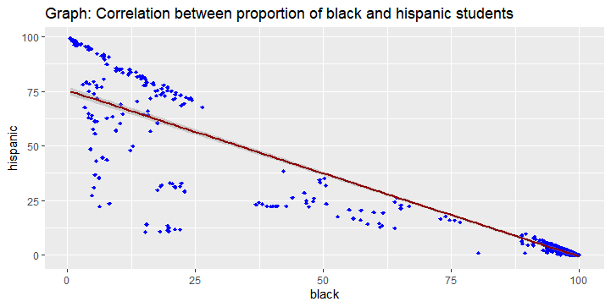

The correlation between the proportion of Black and Hispanic students in the schools in our data set was -0.93, this means the more the Black students in a CPS school in our sample, the lower the fewer the Hispanic students. It is a predictable trend especially with a segregated city like Chicago. The schools that happened to be shut down during school year 2012-2013 mostly located in the majority Black community. As a consequence, the welcoming schools, and the matched schools were also located in those areas. However, another concern we had was about the correlation between the proportion of White and Black students being not too substantial, -0.54. More research needs to be done on why there was such an extreme relationship between Black and Hispanic student proportion in CPS schools.

For the purpose of regression analysis, we decided to use model 5 as our main explaining model. Model 5 was one independent variable fewer than model 4, meaning parental involvement was omitted in model 5. Model 6 was quite similar to model 5 but the proportion of low income students was not included. Model 5 was selected because it has the higher number of observations than model 4. Since our sample size was relatively small, losing 188 observations like in model 4 was too substantial. Since parental involvement was shown statistically significant, we believe omitting it, like in model 5, could be acceptable. Model 6 had only 19 missing observations, however, we think Low-income students is a very important factor to explain the enrollment rate, we decide to choose model 5.

Graph: Regression estimates of selected model

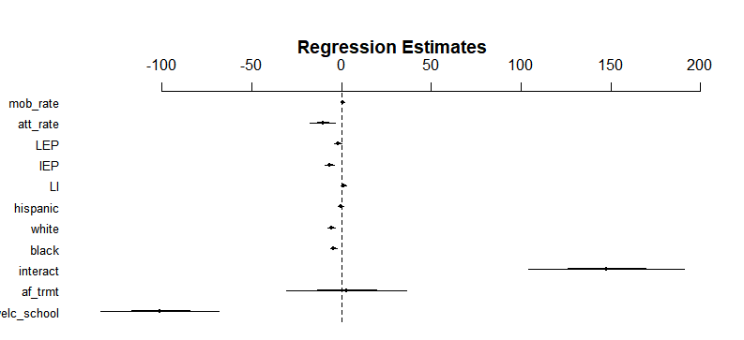

Model 5 estimates that the welcoming school program increased the number of students enrolling in a school by 147.48 at a high significant level (p < 0.000). The proportion of Black, and White students of a school also significantly impacted the enrollment of the schools. Holding other factors constant, 1% point increased in the proportion of Black and White students led to the total enrollment decreased by 4.4 and 5.6 students respectively. The proportion of English learners in the schools made the total enrollment decreased by almost 2 students, ceteris paribus, however, this is at the p=0.05 threshold. When the proportion of students with special needs increased by 1% point, the overall enrollment of the schools decreased by 6 students approximately at p<0.000. In general, from our regression analysis, we could conclude the significant positive impact of the welcoming school program on the welcoming schools, compared with the non-welcoming schools. The welcoming school program overshadowed other school and student’s characteristics in determining the school enrollment.

**Robustness Check**

In order to make sure that our estimates are robust and unbiased, we conducted some tests for robustness check.

Graph: Regression diagnostics

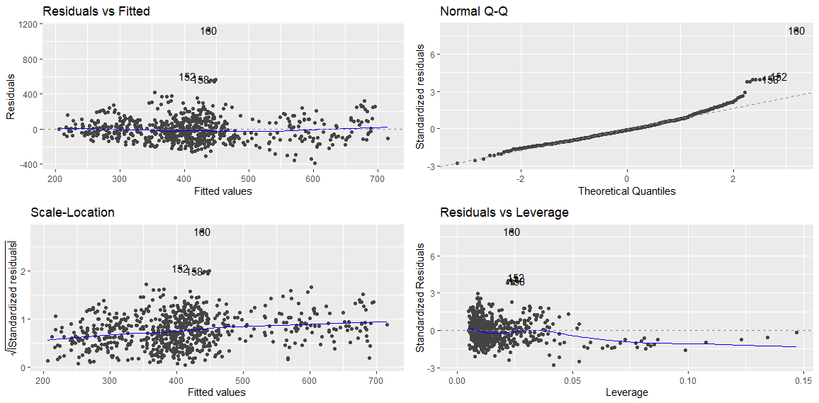

A residuals versus fitted values plot for this model gave us a horizontal line, without distinct patterns, indicating a linear relationship. Using a normal Q-Q plot (standard residuals versus theoretical quantities) shows there are a few outliers, but otherwise the residuals follow a slope of 1 indicating a normal error term distribution. With a scale-location plot (square root of standardized residuals versus fitted values) we found an almost horizontal line. This implies homoscedasticity but not perfectly. We conduct White test to correct the heteroscedasticity issue (Table2, model 5.1). A residuals versus leverage plot indicates that a few values are influential outliers. This abnormal enrollment rate is beyond the expected rate for the model. This is possibly because the school is big in terms of capacity, compared to both welcoming schools and the matched schools. With the big capacity, it is able to take in more students, and in fact, it seemed to be favored by parents that its utility was high.

Table 2: Regression results of total enrollment on other factors for econometric problem

|  |  |  |  |
| --- | --- | --- | --- |
|  | (5)  Total Enrollment | (5.1)  Total Enrollment | (5.2)  Total Enrollment |
| **Welcoming school treatment effect** | | | |
| Welcoming school (Dummy) | -101.23***  (16.49) | -101.23***  (16.848) | -92.37***  (13.834) |
| After treatment (Dummy) | 2.865  (16.685) | 2.865  (21.078) | -1.49  (14.142) |
| Interaction | 147.48***  (21.775) | 147.48***  (22.901) | 145.76***  (18.316) |
| **Students’ demographic characteristics** | | | |
| % Black students | -4.404***  (0.889) | -4.404***  (1.07) | -2.7***  (0.749) |
| % White students | -5.60***  (1.165) | -5.60***  (1.123) | -5.87***  (0.973) |
| % Hispanic students | -0.354  (0.748) | -0.354  (0.845) | 0.912  (0.629) |
| Low-income (%) | 1.211  (0.778) | 1.211  (1.03) | 3.337***  (0.661) |
| English Learner (LEP) (%) | -1.961 **.**  (1.081) | -1.961 **.**  (1.343) | 0.053  (0.911) |
| Special needs (IEP) (%) | -6.50***  (1.25) | -6.50***  (1.077) | -6.201***  (1.048) |
| **School’s characteristics** | | | |
| Parental Involvement (%) | ---------- | ----------- | ----------- |
| Attendance rate (%) | -10.449**  (3.490) | -10.449**  (3.292) | -10.573***  (2.916) |
| Mobility rate(%) | 0.690  (0.513) | 0.690 .  (0.406) | 0.717 . (0.428) |
| Constant | 1749.44***  (364.061) | 1749.44***  (358.005) | 1378.02***  (304.775) |
| Observations | 720 | 720 | 711 |
| R2 | 0.343 | 0.343 | 0.4448 |
| Adjusted R2 | 0.3328 | 0.3328 | 0.436 |
| F-test | 33.6 | 33.6 | 50.91 |
| Note: ‘***’ p < 0.000, ‘**’ p < 0.001, ‘*’ p < 0.01, ‘**.**’ p < 0.05 | | | |

(Note: Model 5: original model selected as a main model to report regression results, model 5.1: Adjusting heteroscedasticity problem of model 5; model 5.2: Omitting significant outlier, a school called Walt Disney Magnet Elementary school, to check for the fitness of the model)

Model 5.1 show the result of the White test. Our regression results still remain robust, especially with the key independent variable of welcoming school-after treatment interaction (see table 2, model 5.1). When observing closely some econometric issues that our model has, we noticed that there were the same extreme outliers shown in all of the four graphs. Those outliers were the data of one same school, Walt Disney Magnet Elementary school. This school has a very big capacity of 1800 students, and has been filled very well throughout the years in our investigation. Located in the northern side of Chicago, this school may be exclusively favored by parents due to its safety and good academic performance. When Walt Disney Magnet Elementary school were removed from the model, our results remained robust (as shown in model 5.2 in table 2). The treatment effect remained highly significant at 0.1% significant level, however the estimate decreased slightly from 147.48 to 145.76. Other factors remained of the same level of significance as the original model. Only the proportion of English learners changed, in this case, it is no longer significant at 90% level of confidence. In summary, excluding Walt Disney Magnet Elementary school increases the fitness of the model (R2 is 44.48% and R2 is 43.96%). However, including it helps us avoid selection bias, and does not affect the ability of the original model to estimate the impact of school closure on welcoming schools’ total enrollment.

For the multicollinearity issue, we first combined Black and Hispanic as one independent variable called minority. However, this method did not work, because the t-value for minority was only 0.167. This showed that Black and Hispanic are too negatively correlated, that they offset each other’s influence on enrollment.

Table 3: F-test results of Hispanic and Black variables against original model.

|  |  |  |  |  |
| --- | --- | --- | --- | --- |
|  | F-stat | P-value | VIF Black | VIF Hispanic |
| Model 5 |  |  | 31.06 | 14.87 |
| Model 5a | 2.1 | 0.147 | 7.18 |  |
| Model 5b | 12.98 | < 0.01 |  | 3.44 |

(Note: Model 5: selected model as a main model to report regression results. Model 5a: Remove the Hispanic variable. Model 5b: Omitting the Black variable)

As a consequence, we switched to another method to deal with a multicollinearity problem for the variables Black and Hispanic, both of their VIFs were greater than 10. We ran an ANOVA in R, comparing the original model 5 with a variation excluding Hispanic (5a) and a variation excluding Black (5b) (Table4). When we removed Hispanic, we reduced our VIF for Black, but it also had a P-value greater than .05, indicating that enrollment is similar across groups. When we removed Black, we reduced our VIF for Hispanic and had a P-value of < 0.01, indicating enrollment was significantly different across groups. Therefore, Hispanic does not have a statistically significant impact on enrollment, meaning excluding Hispanic does not lead to omitted variable bias. We use model 5a to solve for multicollinearity.

Table 4: Regression results of total enrollment with and without Hispanic.

|  |  |  |
| --- | --- | --- |
|  | (5)  Total Enrollment | (5a)  Total Enrollment |
| **Welcoming school treatment effect** | | |
| Welcoming school (Dummy) | -101.23***  (16.49) | -101.67***  (16.456) |
| After treatment (Dummy) | 2.865  (16.685) | 2.619  (16.668) |
| Interaction | 147.48***  (21.775) | 147.56***  (22.763) |
| **Students’ demographic characteristics** | | |
| % Black | -4.404***  (0.889) | -4.036***  (0.431) |
| White | -5.60***  (1.165) | -5.27***  (0.929) |
| Hispanic | -0.354  (0.748) | ----------- |
| Low-income | 1.211  (0.778) | 1.138  (0.763) |
| English Learner (LEP) | -1.961 **.**  (1.081) | -1.807 **.**  (1.031) |
| Special needs (IEP) | -6.50***  (1.25) | -6.56***  (1.249) |
| **School’s characteristics** | | |
| Parental Involvement | ---------- | ----------- |
| Attendance rate | -10.449**  (3.490) | -10.237**  (3.360) |
| Mobility rate | 0.690  (0.513) | 0.720  (0.509) |
| Constant | 1749.44***  (364.061) | 1700.16***  (348.632) |
| Observations | 720 | 720 |
| R2 | 0.343 | 0.343 |
| Note: ‘***’ p < 0.000, ‘**’ p < 0.001, ‘*’ p < 0.01, ‘**.**’ p < 0.05 | | |

We ran the OLS regression again without Hispanic variable. The estimates for all independent variable remained significant and robust. The interaction between welcoming schools and after closure, or our treatment effect independent variable did not change much from the original model (model 5) to model 5a. For both models, turning a school into a welcoming schools increased student’s enrollment by around 148 students, ceteris paribus.

**Conclusion**

In summary, our research found that the welcoming school program significantly boosted enrollment for welcoming schools. Furthermore, the higher the percentage of White students, Black students, Special Needs students, the lower the school’s enrollment. While the program was effective in attracting students, more students does not imply higher quality education or better educational outcomes.

There are some potential sample selection issues since we choose not to include the closing special education schools based on their low enrollment rates. We avoid sample selection in our control group by choosing matching schools with similar characteristics to the welcoming schools. Those characteristics are: within 1.3 miles of a closing school, having capacity to accept students from that school, and having an equal or better performance score than that school. These are similar requirements to the ones CPS used to choose welcoming schools.

Besides some econometrics issue that we were able to solve, there are still some limitations to this research. We leave out ISAT (state test) scores because the data is not public for post-2014 school years. We can potentially use the 2014 year as our post-treatment difference, but a few details from the literature suggest that would be problematic. Firstly, there is a transitional effect that reduces test scores immediately after a student switches schools. Furthermore, the schools require an adjustment period to properly allocate funds and adjust teachers. Finally, since the closing schools were closed partially based on poor performance, the welcoming schools were accepting lower performing students, lowering the average test scores for a few years immediately following the closures. We also leave out parental involvement from our main model, since it was poorly measured in some years. Including it lowers our sample size and reduces the explanatory power of our model, since the Illinois Board of Education stopped measuring parental involvement in 2018. Moreover, we wanted to include the average distance from home to school, since the literature suggests that this has an impact on enrollment rate, but the data is not available.

More research is needed to better understand how the transition went for families and students. It is important to investigate how the affected students do academically, socially, and behaviorally in their new school environments, and to unpack which school characteristics matter most for improving student outcomes. We further encourage more research on individual level student data. This would give a clearer picture of what is most strongly affecting students through transitions, and better inform districts on best practices for the future. Lastly, not much is known about how closing schools affects teachers and other staff or the impact closing schools has on the composition of the entire school staff. Reaching a better understanding of the impact of closing schools on families, students, and staff could help districts facilitate better educational experiences and student outcomes in the future.

**Reference**

Brummet, Q. (2012). The Effect of School Closings on Student Achievement

Carlson, D., Lavertu, S. (2015). School Closures and Student Achievement: An Analysis of

Ohio’s Urban District and Charter Schools

Chicago Data Portal. Chicago Public Schools – Elementary School Progress Report Card

(2012-2013)

Grau, N., Hojman, D., Mizala,A. (2012). School closure and educational attainment: Evidence

from a market-based system. *Economics of Education Review, 65*

Illinois Board of Education. Report Card Public Data

*https://www.isbe.net/Pages/Illinois-State-Report-Card-Data.aspx*

Kirshner, B., Gaertner, M., and Pazzoboni, K. (2010). Tracing Transitions: The Effect of High

School Closure on Displaced Students. *Educational Evaluation and Policy Analysis,*

*32(3)*: 407–429

Larson, M. (2014). "Does Closing Schools Close Doors? The Effect of High School Closings on

Achievement and Attainment"

Mari, J. (2013, January 24). *Space Utilization: Does central office use 36 as the average*

*maximum class size or not?*

Philadelphia Research Initiative. (2011, October 19) *Closing Public Schools in Philadelphia:*

*Lessons from Six Urban Districts.*

Samuels, C. A. (2019, February 21). *Study Warns of Limited Savings from Closing Schools.*

The Research Alliance for New York city school. (2015). High school closure in New York city:

Impacts of students’ academic outcome, attendance, and mobility. Kemple,J.

The University of Chicago Consortium on Chicago School Research. (2015). *School Closings in*

*Chicago*. Chicago, IL: Cowhy et. al.

The University of Chicago Consortium. (2009). *When Schools Close: Effects on Displaced*

*Students in Chicago Public Schools.* Chicago, IL: Gordon, F.M., de la Torre, M.,

Cowhy,J.R., Moore, P.T., Sartain, L. When Schools Close: Effects on Displaced Students in Chicago Public Schools

The University of Chicago Legal Forum. (2014). *Disparate Impact, School Closures, and Parental Choice*. Chicago, IL: Garnett, N.S.

Vevea, B., Lutton, L. (2013, May 16) *Fact Check: Chicago school closings.*